Assignmnet-11.5
Name:R.Ashwitha
Hall Ticket-Name:2303A51340
Batch-20
Task1
Prompt
“Generate a Python program for a Contact Manager using a list (array) that supports add, search, and delete operations. Then implement the same program using a linked list class with node objects. Include comments and compare performance of both approaches.”
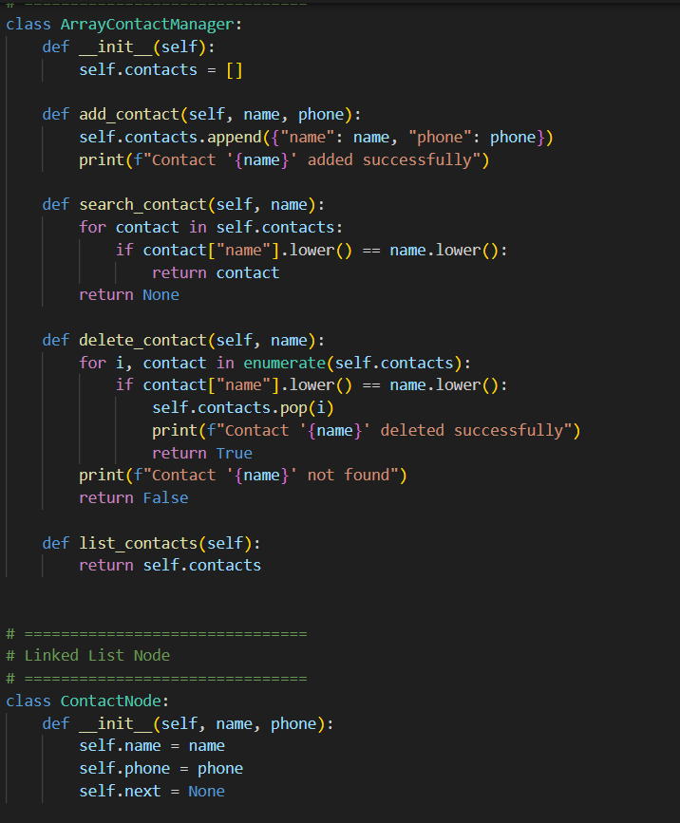
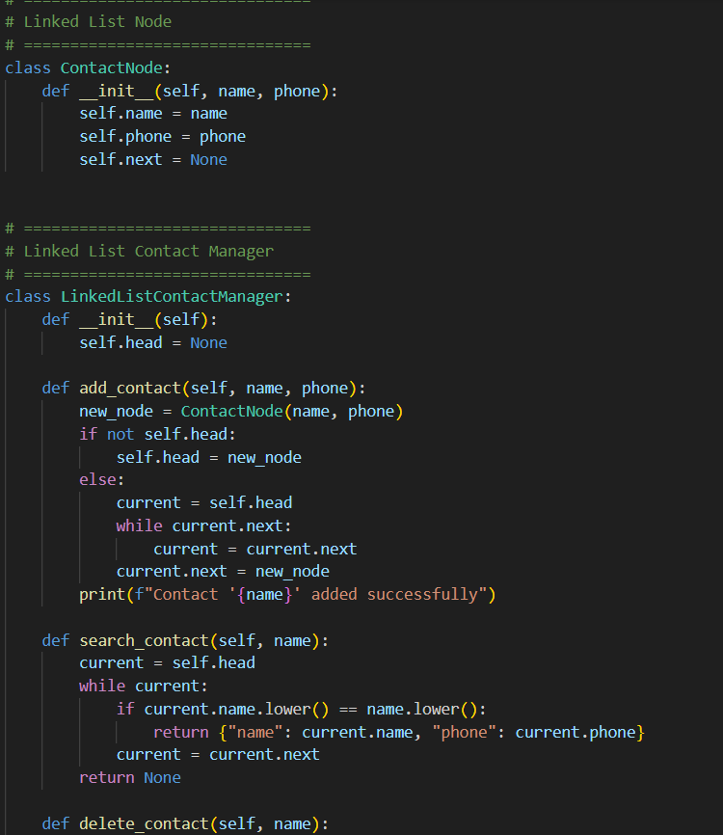
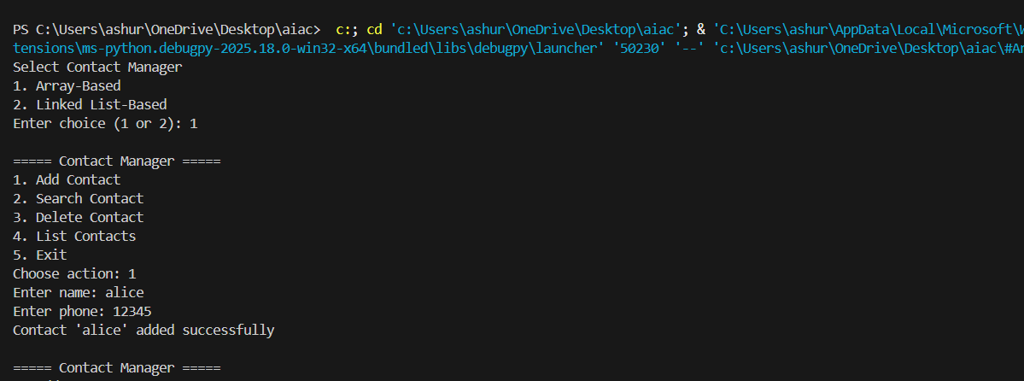
Analysis
The prompt clearly specifies two implementations, helping the AI generate structured solutions.
By mentioning operations explicitly, the output becomes task-focused and avoids unnecessary code.
The comparison requirement encourages the AI to include conceptual explanations, not just syntax.
AI assistance speeds up writing search/delete methods, which often involve loops or pointer updates.
This task shows how arrays are faster for searching but linked lists are better for insertions/deletions.
It demonstrates how AI can support both coding and conceptual understanding.
Task2
Prompt
“Create a Python program implementing a queue for book requests using FIFO. Extend it to a priority queue where faculty requests have higher priority than students. Implement enqueue() and dequeue() methods and simulate sample requests.”
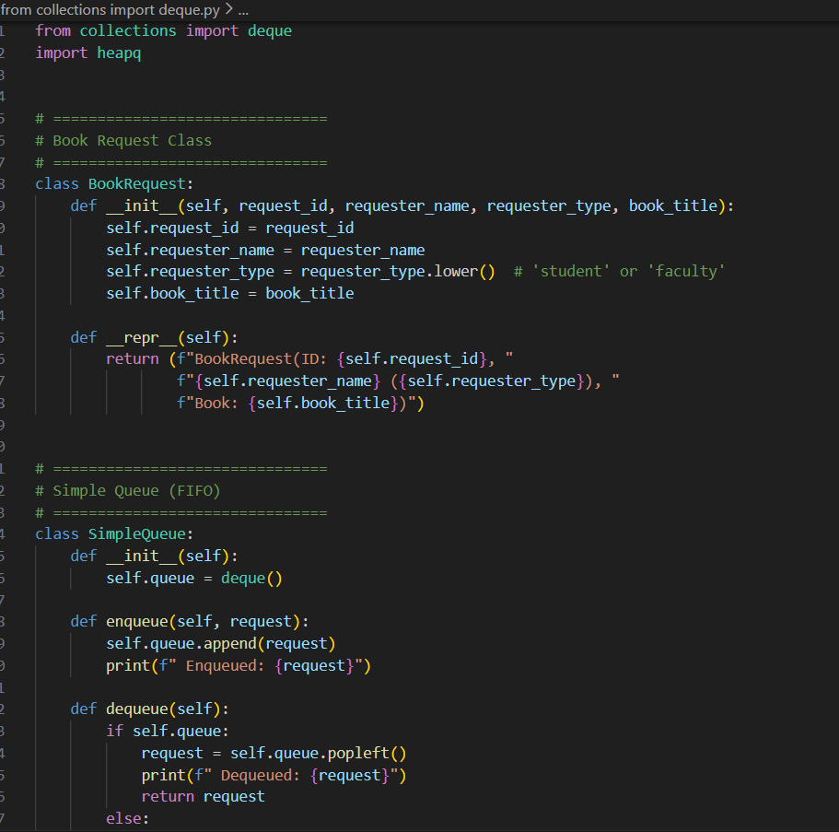
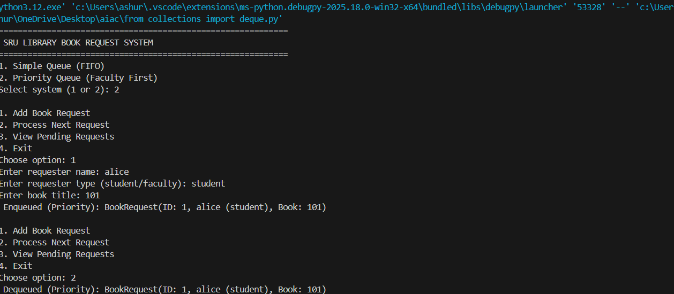
Analysis
This prompt helps the AI distinguish between normal queues and priority queues.
Specifying FIFO ensures the generated queue behaves correctly.
The priority condition ensures the AI includes sorting, heap usage, or priority values.
Simulation instructions make the output practical and testable.
AI-generated methods reduce manual coding time for queue logic.
The task highlights real-world scheduling problems solved using queues.
Task3
Prompt
“Write a Python program implementing a stack to manage IT support tickets. Include push, pop, and peek operations. Add functions to check if the stack is empty or full and simulate resolving five tickets.”
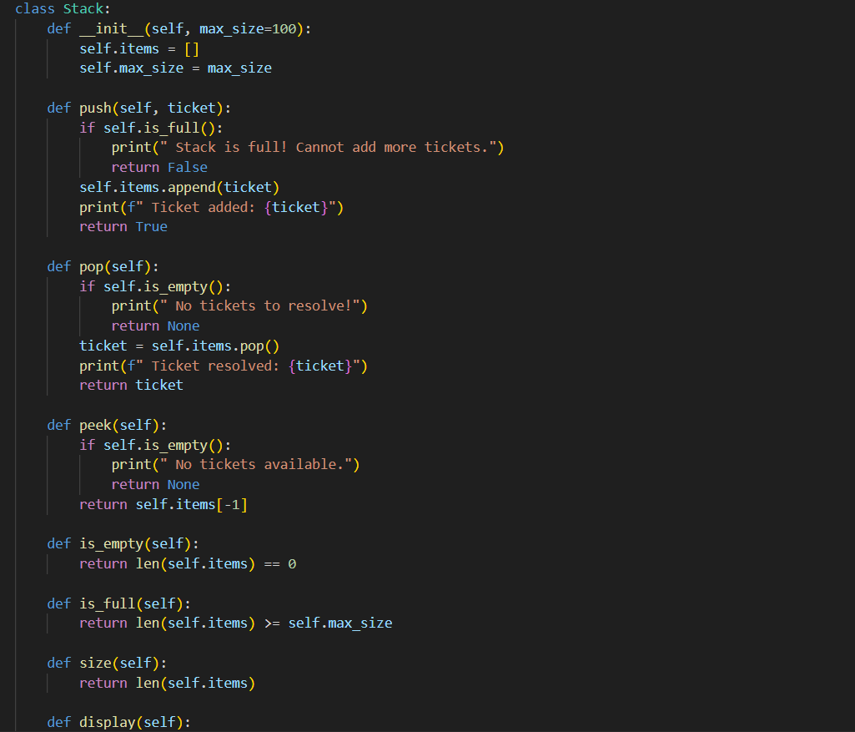
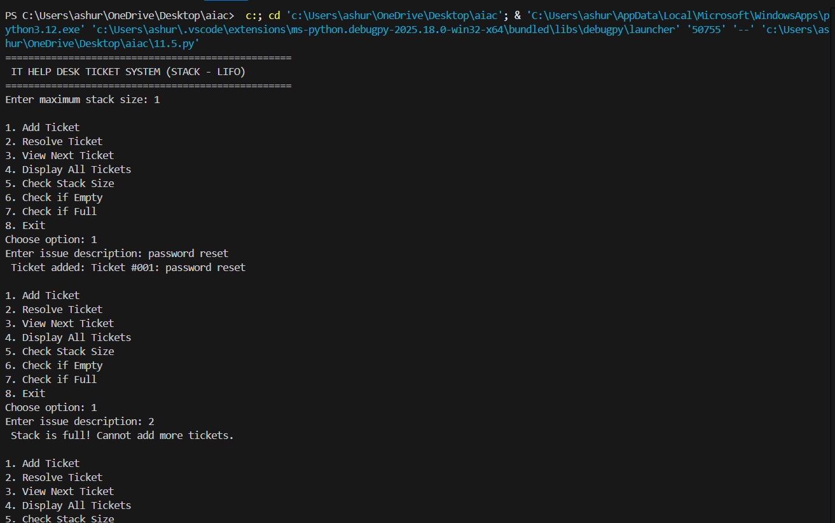
Analysis
The prompt clearly states LIFO behavior, guiding AI toward stack logic.
Mentioning required operations ensures a complete implementation.
Adding simulation forces the AI to include test cases and outputs.
AI suggestions often include built-in list usage or class-based stacks.
This task reinforces the difference between stacks and queues.
It also demonstrates how AI can suggest additional validation methods.
Task4
Prompt
“Generate a Python implementation of a hash table class with insert, search, and delete methods. Use chaining for collision handling and include comments explaining how hashing and collisions work.”
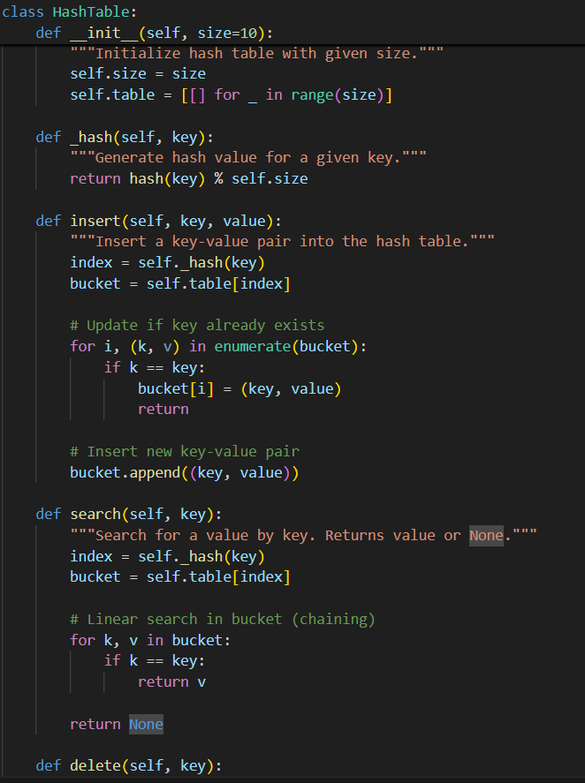
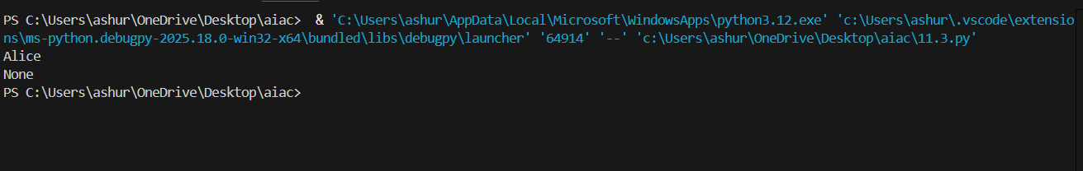
Analysis
This prompt ensures the AI includes collision handling instead of a basic dictionary.
By specifying chaining, the AI usually uses lists at each index.
Comment requirement improves readability and educational value.
AI-generated hash functions may vary, showing different implementation ideas.
The task helps students understand indexing and time complexity.
It shows how AI can assist in building more advanced data structures.
Task5
Prompt
“Suggest suitable data structures for attendance tracking, event registration, library borrowing, bus scheduling, and cafeteria order queue. Justify each choice in 2–3 sentences and implement one feature in Python.”
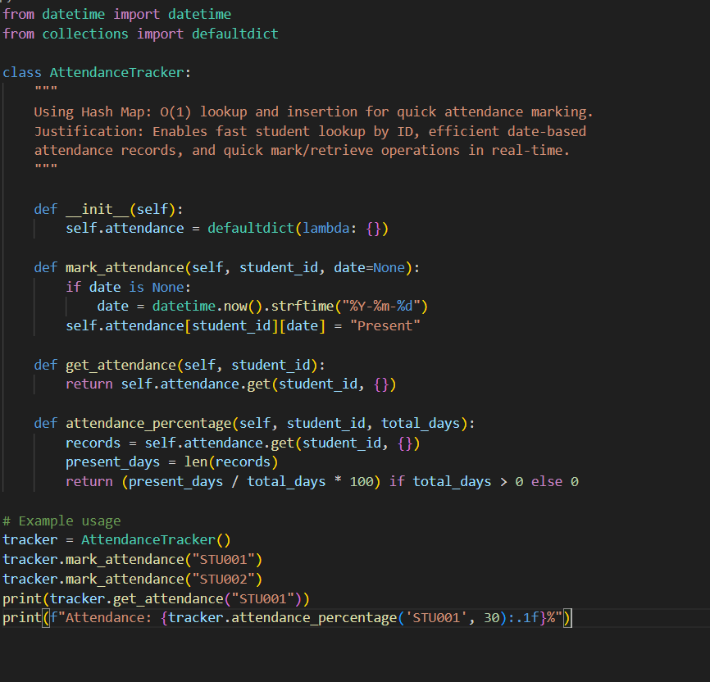
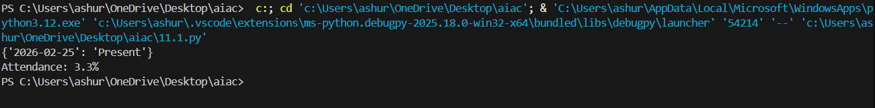
Analysis
This prompt focuses on design thinking rather than only coding.
It encourages the AI to explain why a data structure fits a problem.
Justification requirements improve conceptual clarity.
Implementation of one feature keeps the solution practical.
AI assistance helps in selecting efficient structures like queues, hash maps, or trees.
This task shows how AI supports decision-making in software design.

